Diversity of Today’s Suburban Areas
Name
Institution affiliation
Course name
Instructor
Date

Diversity of Today’s Suburban Areas
 | Plano | Sugar land
Population | 287,677 | 118,488
Population percent change since 2010 | 10.7% | 9.9%
Land area in square miles | 71.58 | 32.38
Population per square mile | 3630.0 | 2434.2
Percent white alone, not Hispanic or Latino | 52.4% | 42.7%
Percent aged 5+ whose language spoken at home is other than English | 35.3% | 43.0%
Percent households with broadband internet subscription | 93.9% | 94.7%
Median age
Median household income | $95,602 | $121,274
Per capita income past 12 months | $47,840 | $53,529
Percent persons in poverty | 6.8% | 4.2%
Owner-occupied housing rate | 59.1% | 81.4%
Percent without health insurance under 65 years old | 12.5% | 7.7%
Percent children getting free or reduced-price lunches
Percent children receiving food stamps | 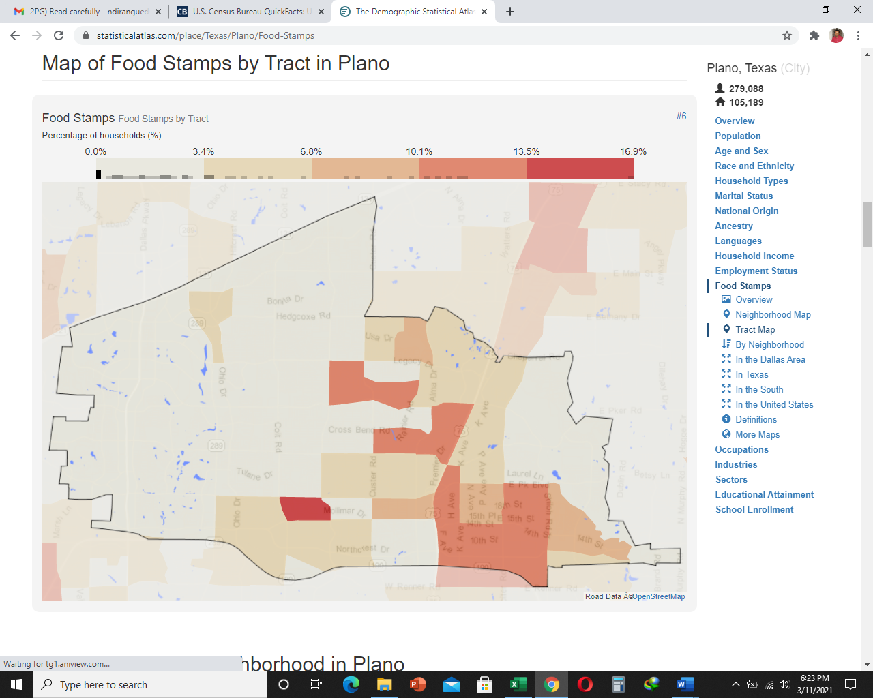 | 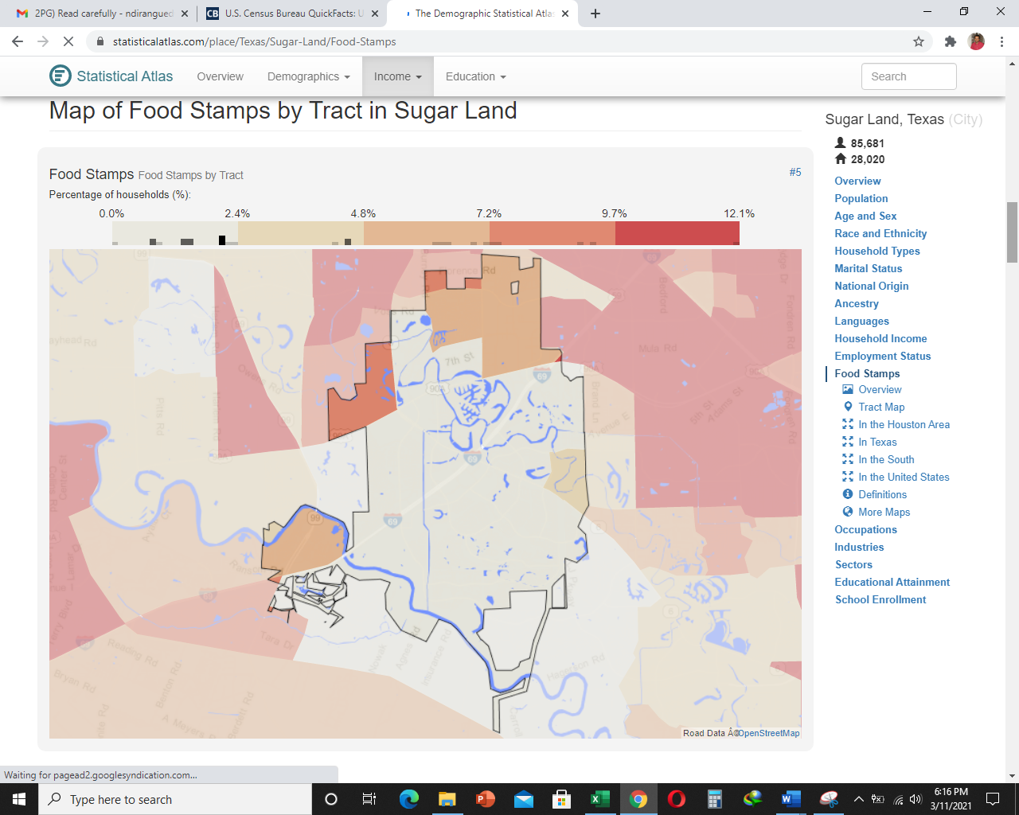
Image of race and ethnicity by tract | 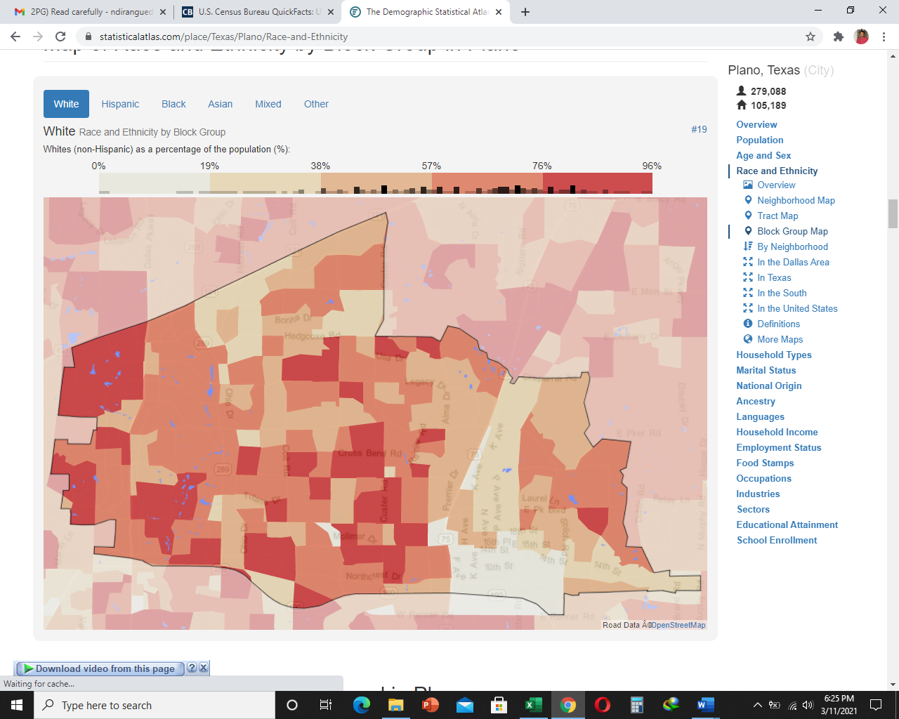 | 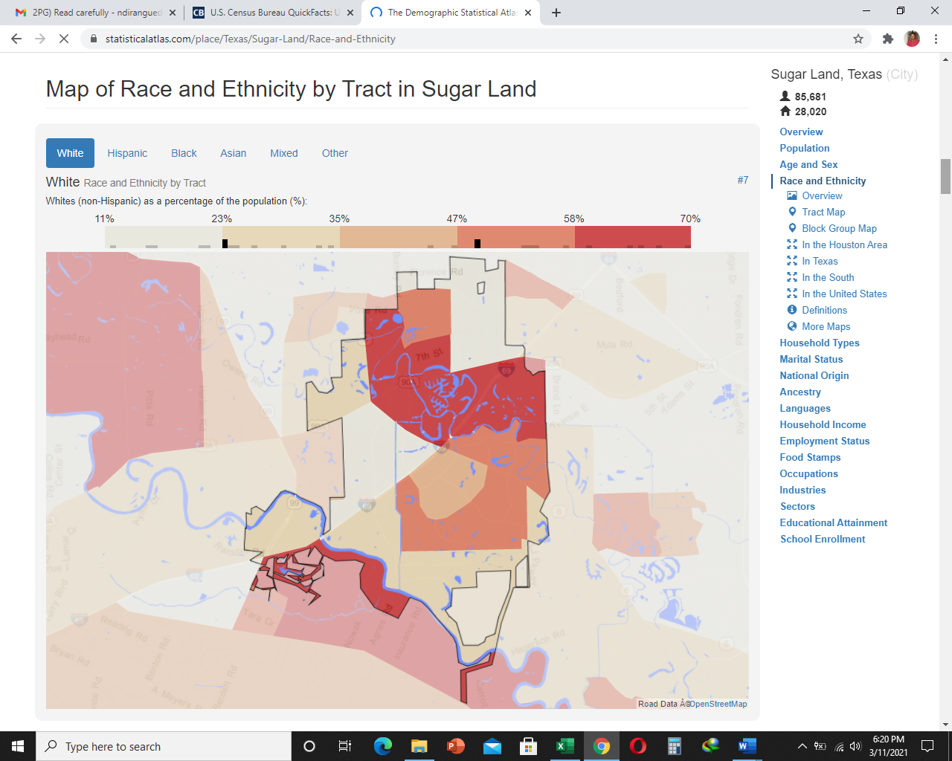
Unemployed 25-64 years old | 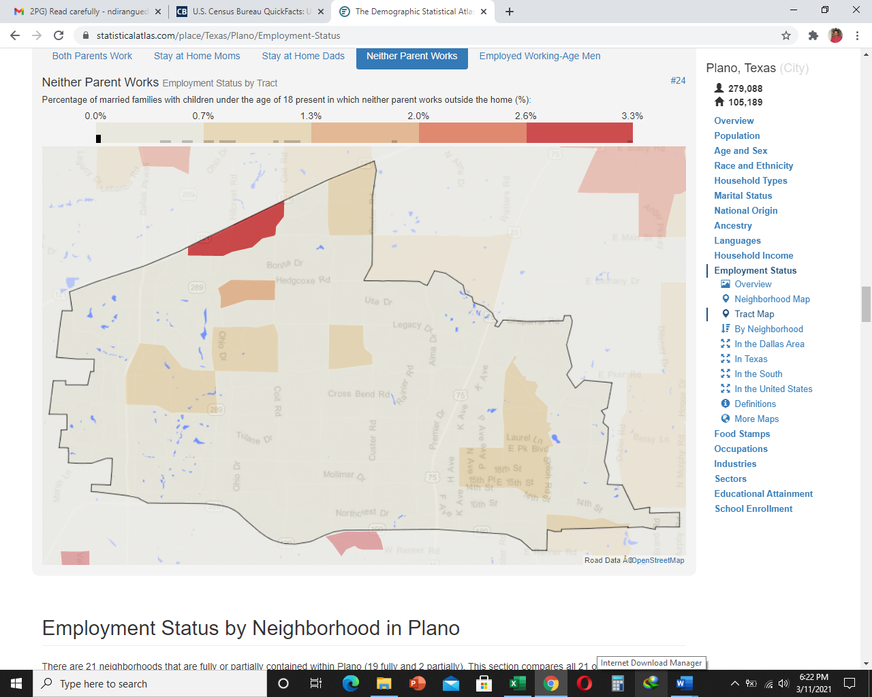 | 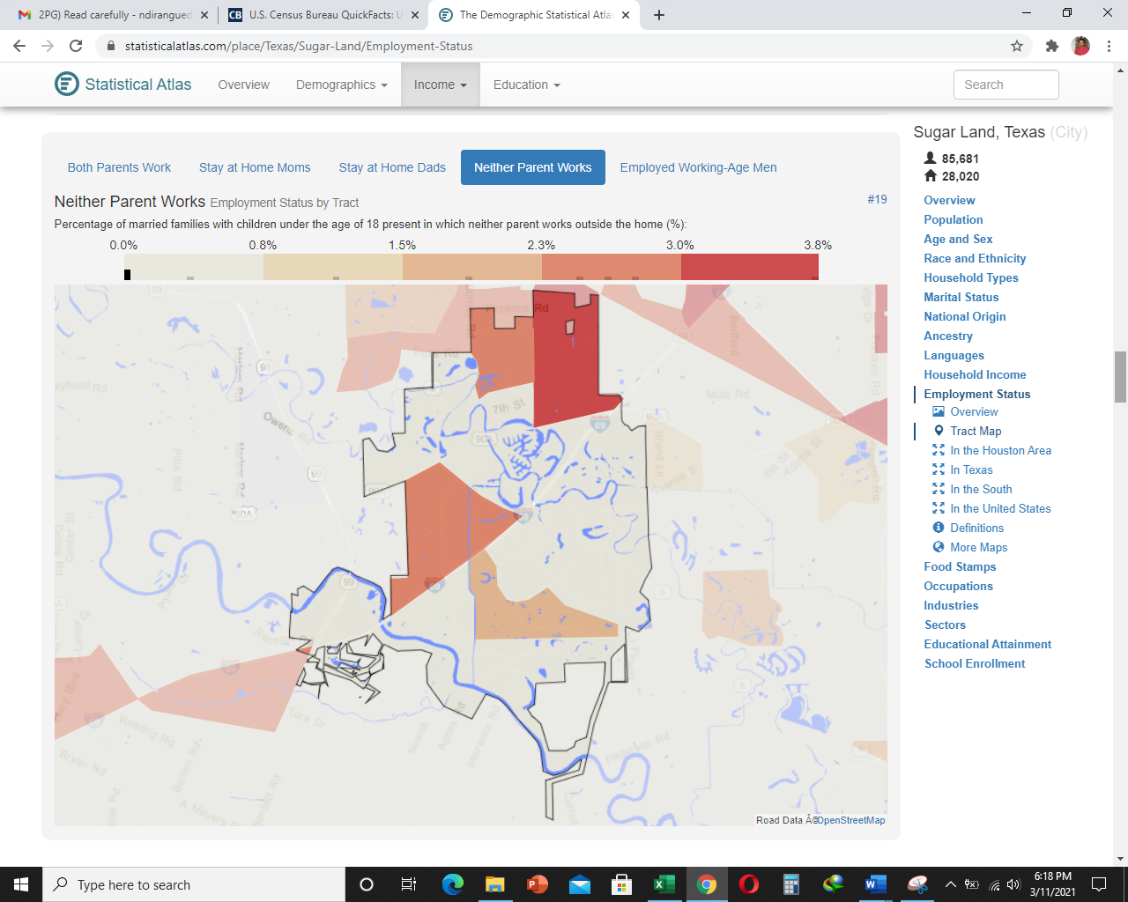

The two suburban cities in Texas are homogenous. There are very slight differences between them, showing that almost everything happening in one city happens in another. For example, the population growth rate in both cities is similar. Some of the similarities between suburban areas and central city settlement patterns include a large population of people is within the central areas, and there is a diversity of race and ethnicity. Yes, I expected to find such data considering that suburban areas comprise people living average livelihood since they earn an average income. Issues like poverty, lack of health insurance, and population, which is commonly resulted from unemployment.
Challenges the poor face in the suburbs that wealthier people may avoid include: First, affordable housing. Housing is a challenge to many poor people in the suburbs. Individuals living in the suburbs are low-income earners. Some of them unemployed worsening the situation (Gaines, 2010). Therefore, getting affordable houses for their families becomes a great challenge. Second, unemployment is a challenge that people in the suburbs face. The job opportunities available from time to time can't serve the large population living in the suburbs (Gaines, 2010). This condition leaves many of these individuals languishing in poverty. Third, diet-related health challenges. The population in the suburbs comprise of low-and-middle-income earners. It means that the population struggles to get nutritious foods because it is difficult to afford them. Forth, lack of proper healthcare services. The majority of people living in the suburbs lack health insurance. Access to proper healthcare is a challenge (Gaines, 2010). Nevertheless, for the poor living in the central cities, these challenges are much worse since life in the central cities comprises the wealthier population. Services provided in the central cities focus on wealthy people and not on the poor.

Sources
Gaines A. C. (2010). Trouble in the Suburbs: Poverty Rises in Areas Outside Cities. Retrieved March 11, 2021 from, https://www.americanprogress.org/issues/poverty/news/2010/10/27/8457/trouble-in-the-suburbs/
https://statisticalatlas.com/United-States/Race-and-Ethnicity
https://www.census.gov/quickfacts/fact/table/US/PST045219
https://statisticalatlas.com/United-States/Overview

